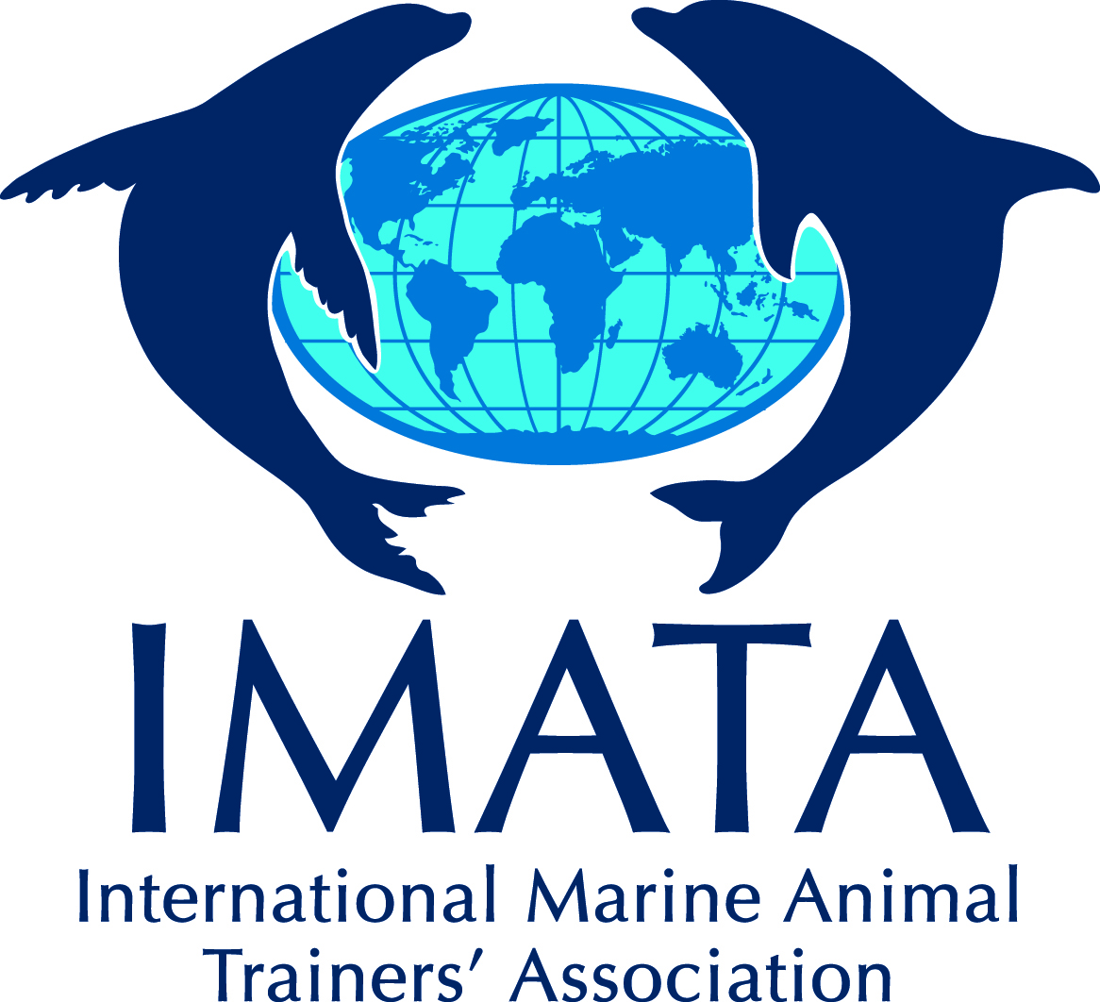

2017 IMATA Research Grant
Co-Principal Investigator’s Statement of Organizational Support

The (Name of Organization ) has reviewed the 2017 International Marine Animal Trainers Association (IMATA) Research Grant Application and project entitled (Research Investigation Title) and commits itself to providing Co-Principal Investigator, (Co-PI Name), the time, resources, and financial support stated in the Research Grant Application should it be selected for funding.

The above-named Organization further acknowledges that either the Co-PI or PI is a current “Professional” IMATA member and that it’s Institutional Animal Care and Use Committee (IACUC) or equivalent thereof has reviewed this investigation and has granted approval if necessary*. By signing below, this Organization certifies that it takes full responsibility for the Co-Principal Investigator and for following lawful procedures regarding the IACUC and Animal Welfare approvals for their portion of the investigation.

Printed Name of CEO/Director Organization Name

Signature of CEO/Director Date

Printed Name of Co-I Title

Signature of Co-PI Date

*IACUC approval is desirable for any in-situ and ex-situ research investigations, but is required for any in-situ or ex-situ investigation in which animals are to be involved in invasive procedures and/or procedures that may result in pain, harm, distress, and/or altering of behavior (including anytime an animal in the wild is sedated or anesthetized). This generally excludes samples obtained during regularly scheduled veterinary or husbandry procedures or emergency medical procedures.

If the methodology defined in the above-named research investigation requires IACUC approval, the Co-Principal Investigator must have gained this approval from his/her organization affiliation. If the organizational affiliation does not have an established IACUC, they must be affiliated with a University, Aquarium/Zoo, or other body which has gained IACUC approval for this Research Investigation.

